GOOGLE CLOUD LAB
1)
(a) Execute a Python Program in Google Cloud Shell
AIM:
Run a Python application using a cloud-based environment.
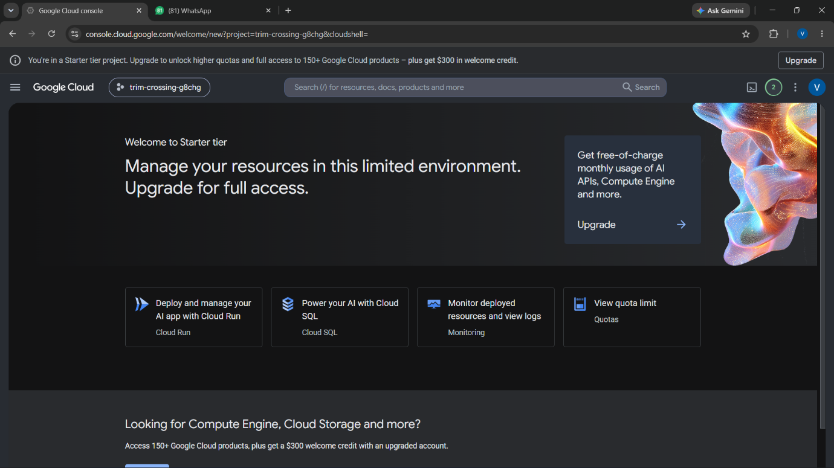
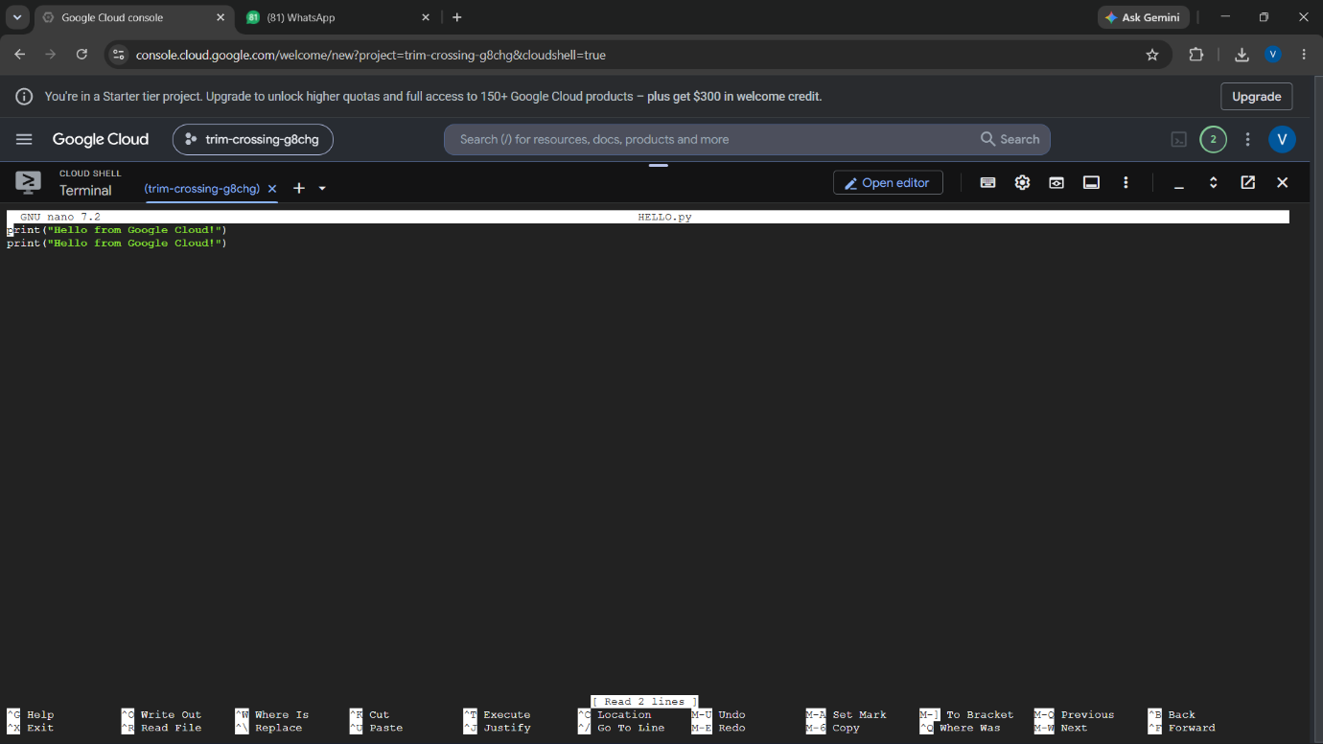
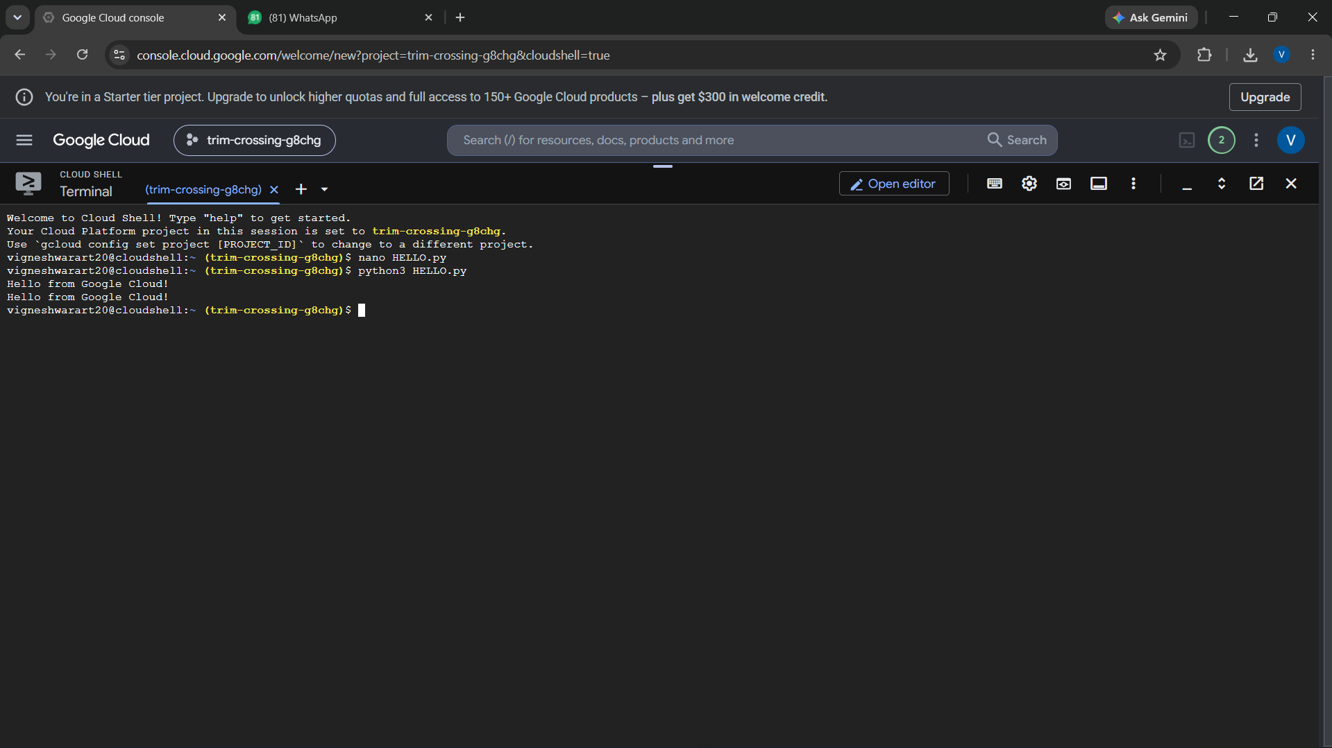
1)
(b) Addition of two numbers using python in Google Cloud Shell
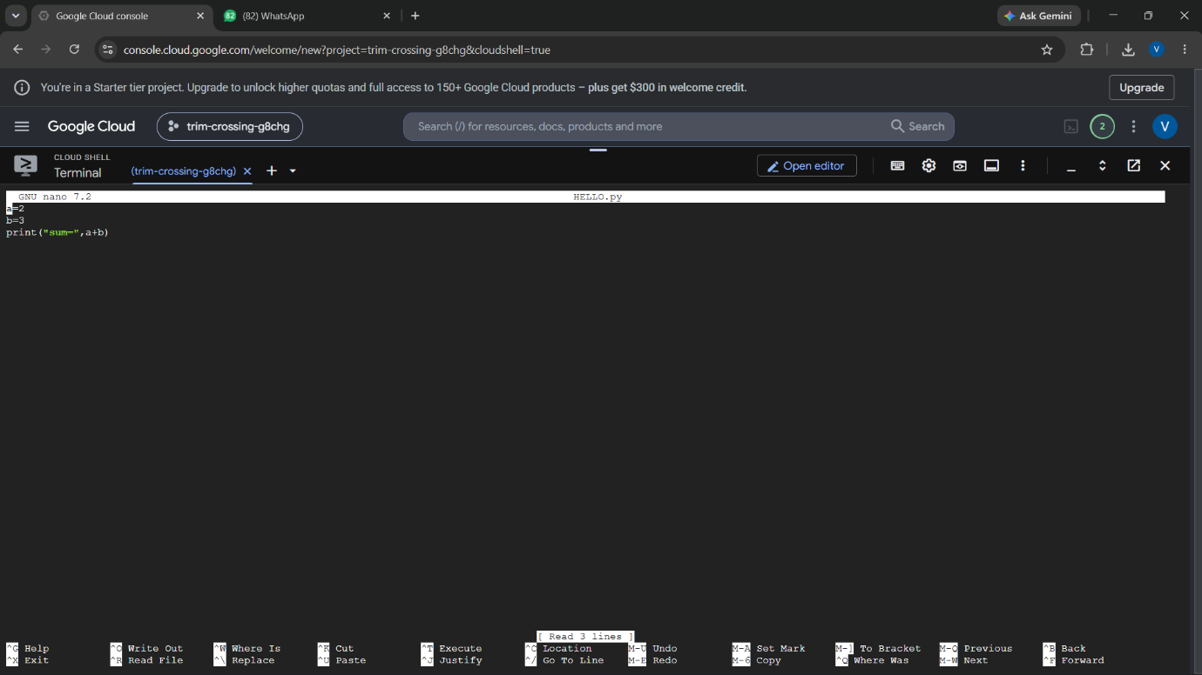
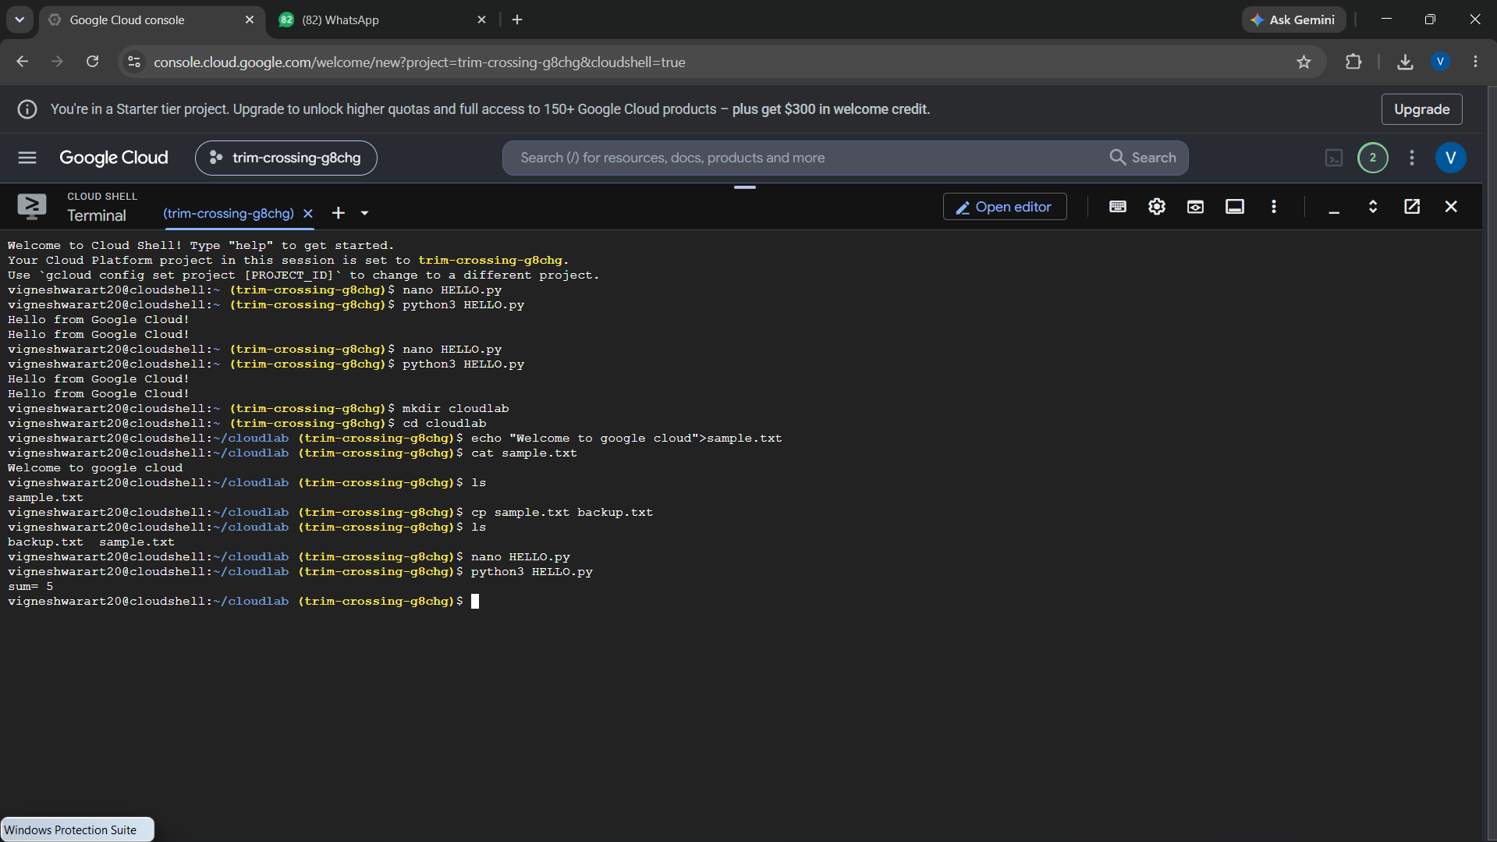
2. Create and Manage Files in Cloud Storage of Cloud Shell
AIM:
Demonstrate cloud-based file creation and management.
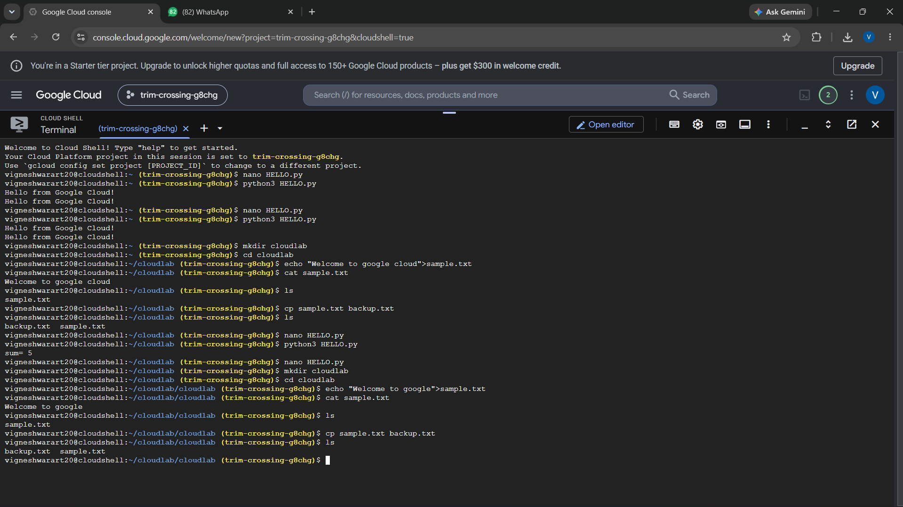

3.Run a Simple Web Server in Google Cloud Shell
AIM:
Host and access a simple webpage from a cloud development environment.
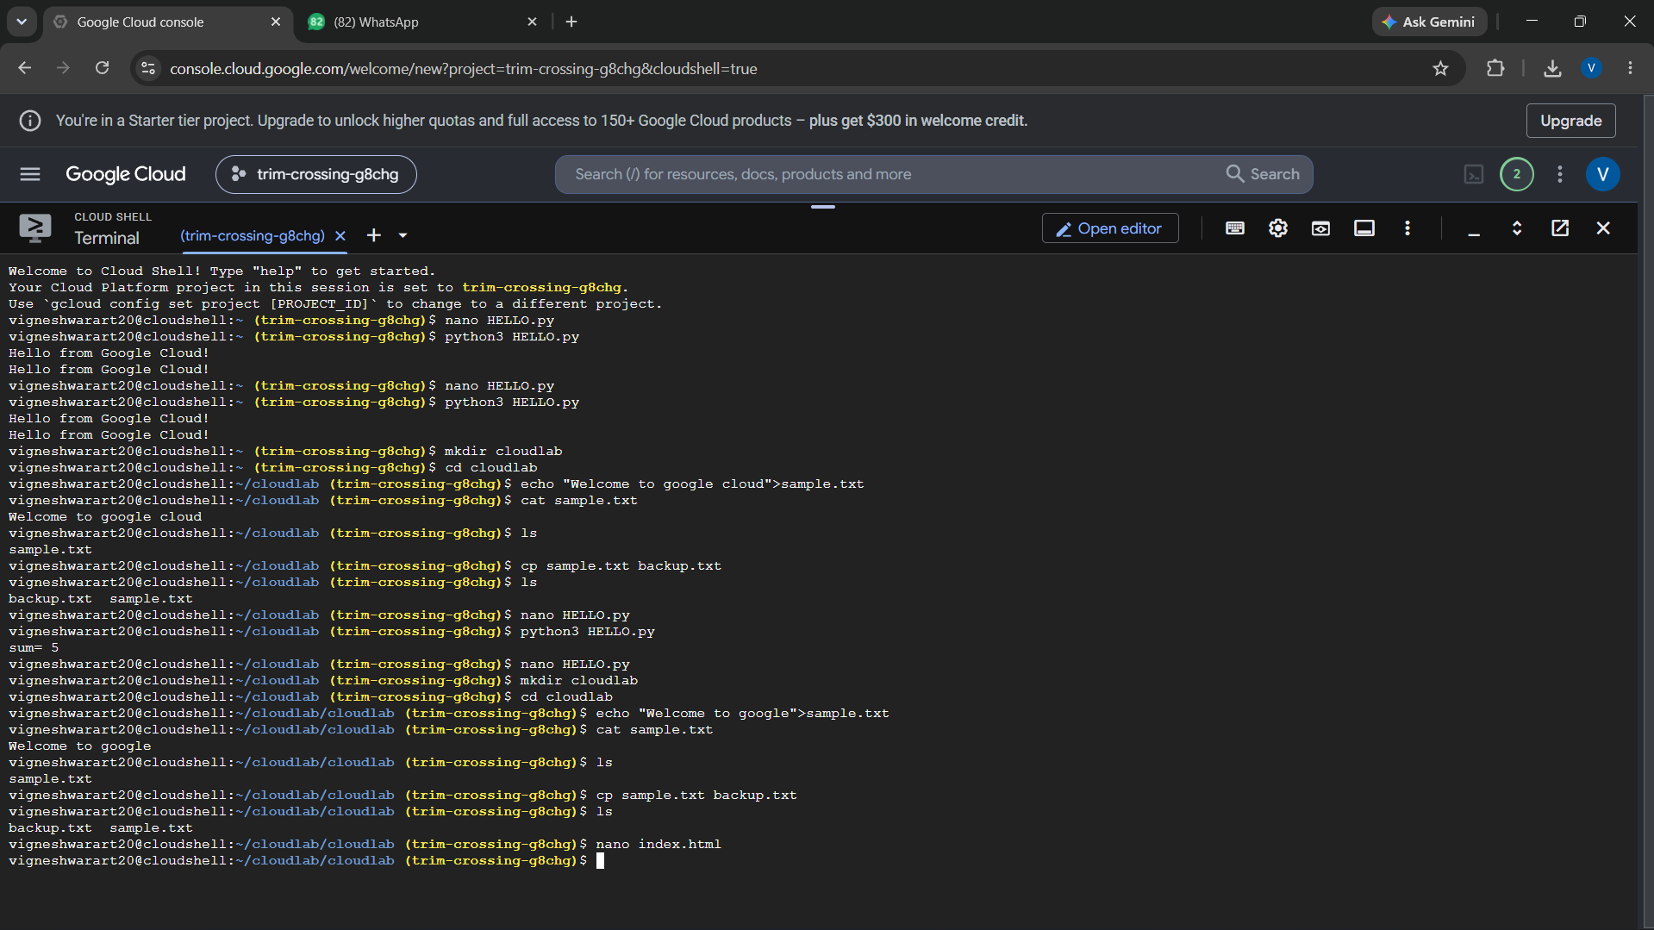
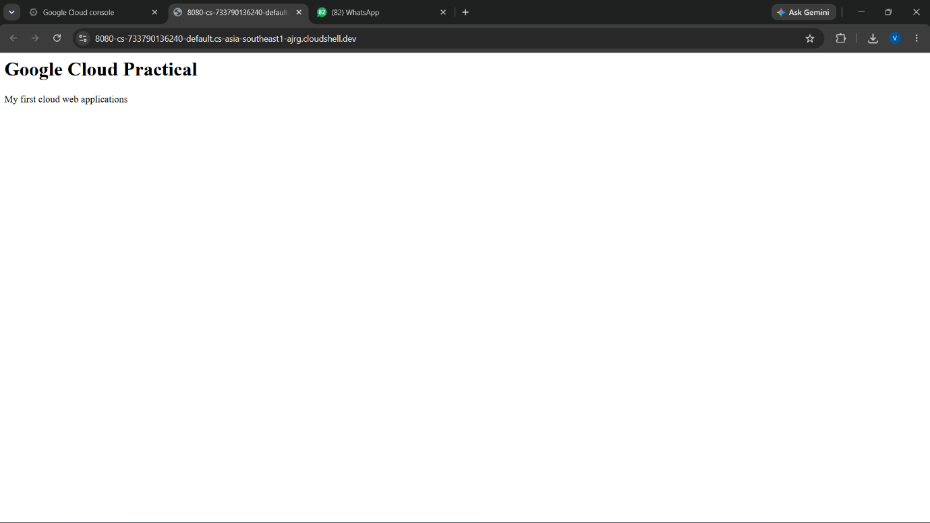

4. System Resource Monitoring in Google Cloud Shell
AIM:
Demonstrate monitoring of CPU, memory and storage resources in a cloud environment.
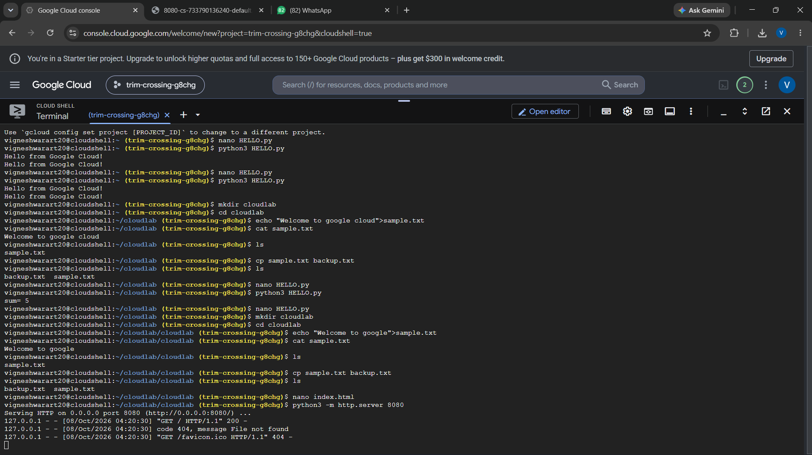

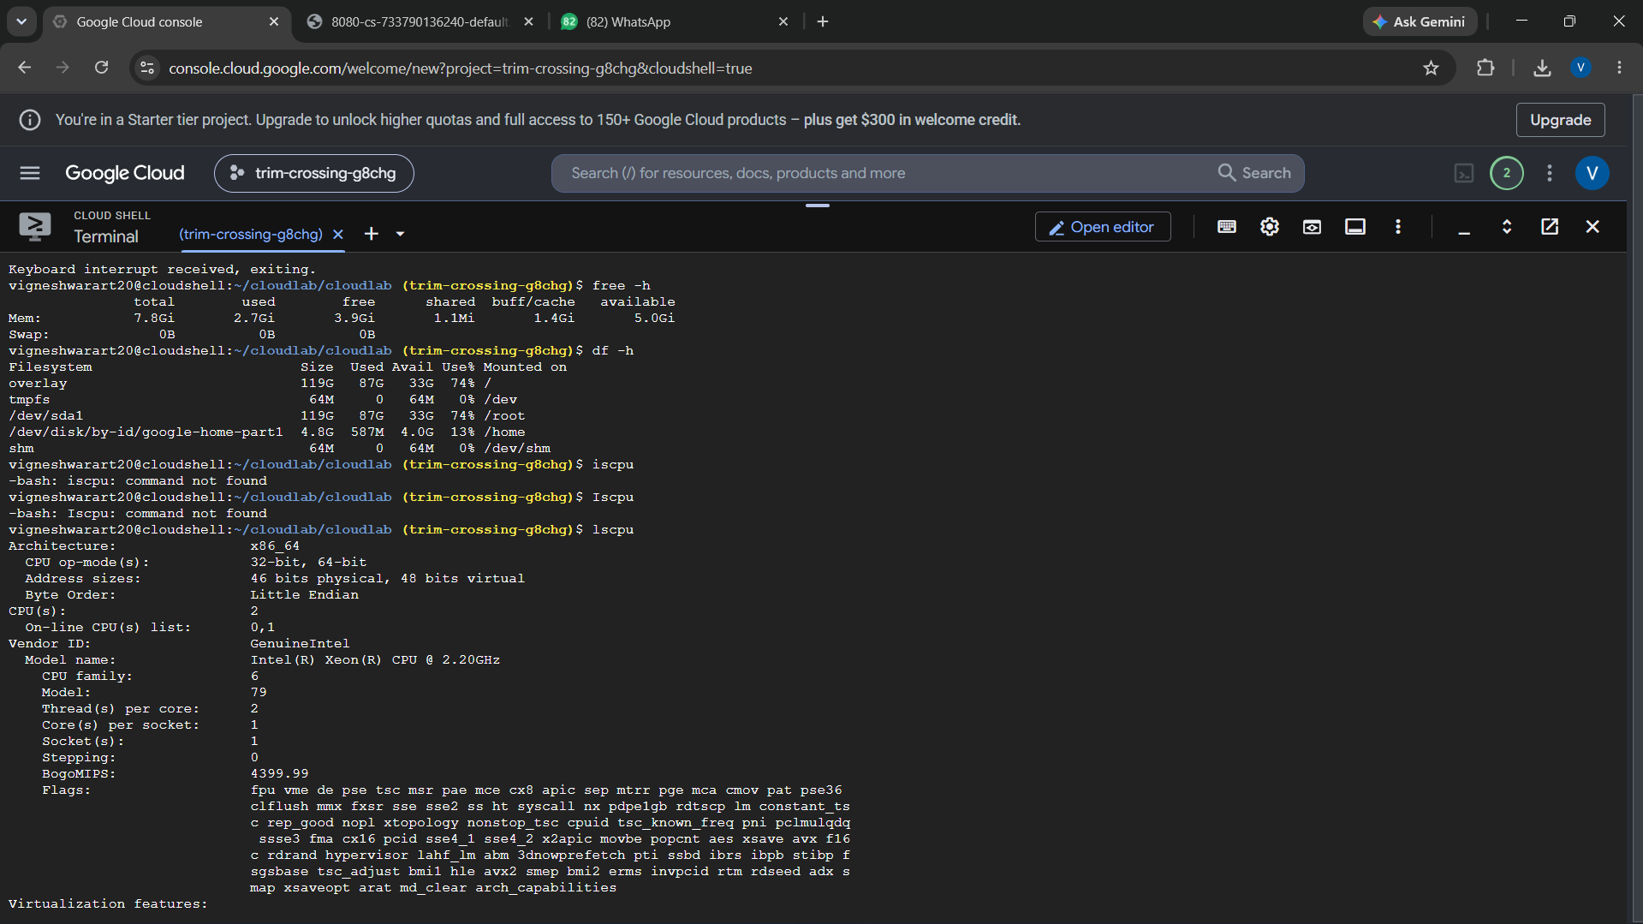
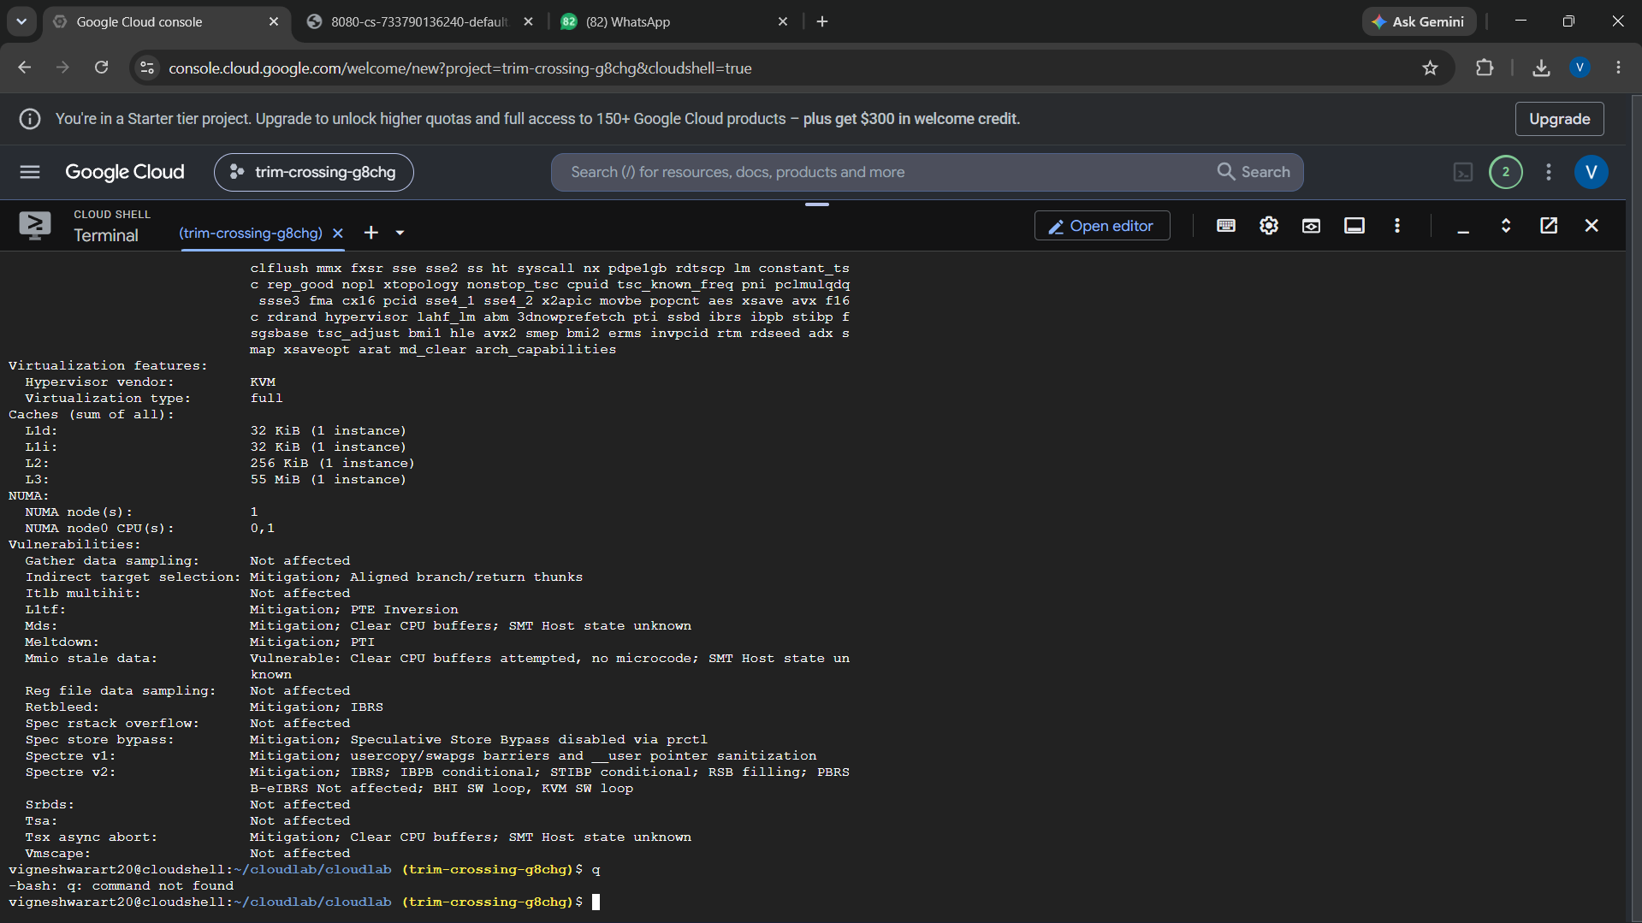
5. Execute a C Program in Google Cloud Shell
AIM:
Compile and execute a C application in a cloud-based environment.
